MHFRP Online Training and Time Study Overview

A time study sampling process to identify and quantify the amount of time and effort spent by agency staff on allowable Medicaid administrative and outreach activities.

Process

1. Sampling Methodology – InteCare randomly selects a week for each quarter that the time study will take place as well as a random selection of sample personnel that will complete the time study
2. Training Methodology – Information provided to the quarterly selected participants details how the MHFRP time study works and the role of each as it relates to completing the time study instrument and overseeing the process.
   1. The two weeks prior to the selected week indicates the ‘Training Weeks’, each participant will have this time to complete the 30-45 minute presentation.
   2. InteCare sends a PowerPoint to upload
   3. 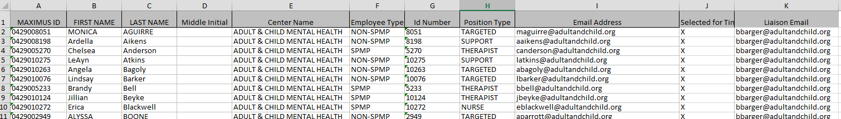After the selection of sample participants, InteCare will upload these participants online (see example of spreadsheet below)
   4. Participants receive an e-mail containing a personalized link to their training which is interactive with three quizzes that must be passed in order for their training completion to be recorded.

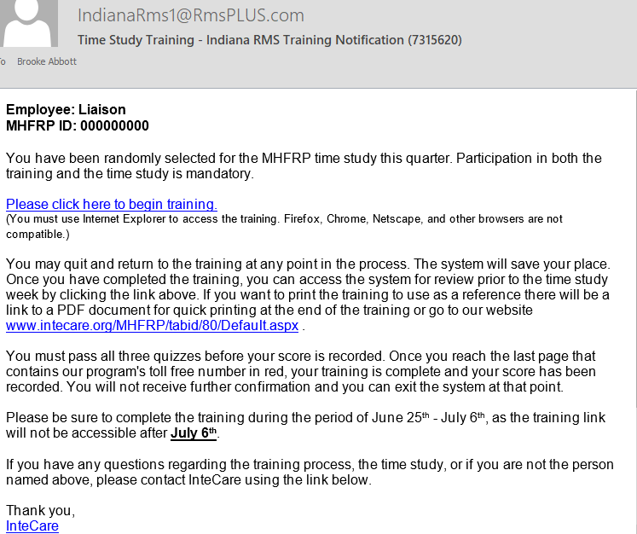

* 1. Time Study training is conducted on a quarterly basis and each sample participant is required to complete training at least once within the designated four quarter training period *\*\*If they have completed the training within the last year, they will not receive a link for the training\*\**
  2. **Tracking – Will need a report indicating who has completed the training within the last four quarters and be able to record this electronically for each quarter.**

1. Time Study Methodology – the actual data from the time study week are captured on the electronic Time Study tool.
   1. 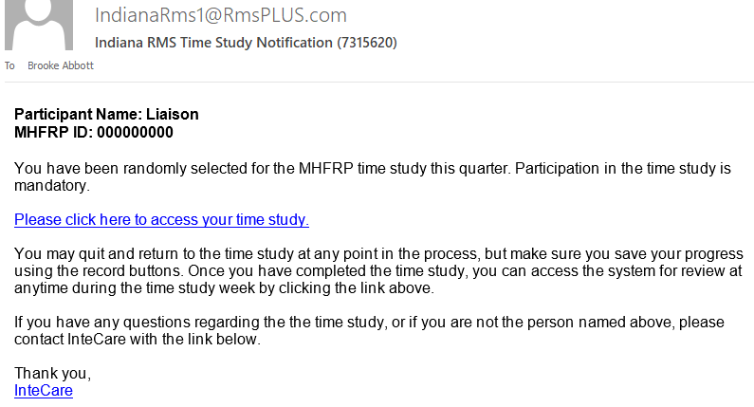Each participant receives an email containing their personalized link to their Time Study
   2. The liaison will ALSO receive these links for their participants (if a participant can’t find their link, the liaison will forward this link to them)
      1. *Right now, if an agency has 33 selected participants… they receive 33 different emails. I would like to eventually figure out a way to put each personalized link in ONE email. ☺*
   3. Each day is broken into 15 minute segments over the seven day sample week, with the time study participant responsible for completing at least 8 hours on each day of the sample week.
   4. (They may code up to a maximum of 12 hours and are required to code non-worked days as well as regular work days…every increment should have an activity and code selected in order to submit)
   5. Screenshots of Online Time Study Tool below

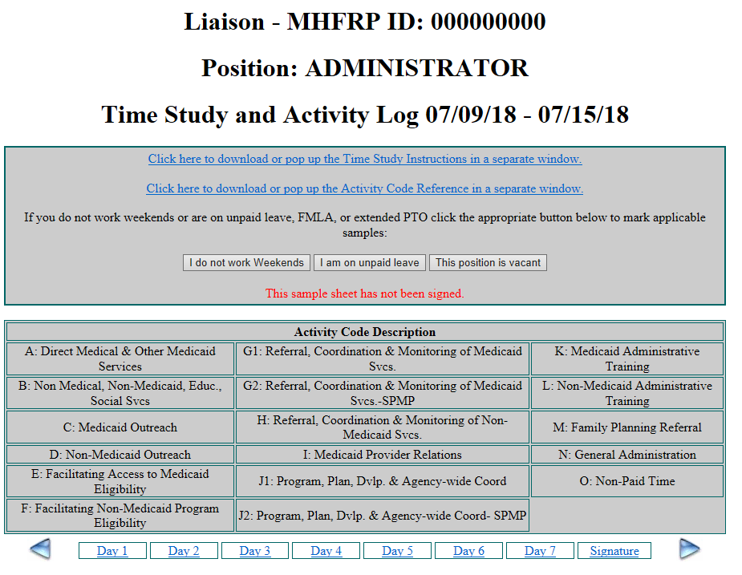

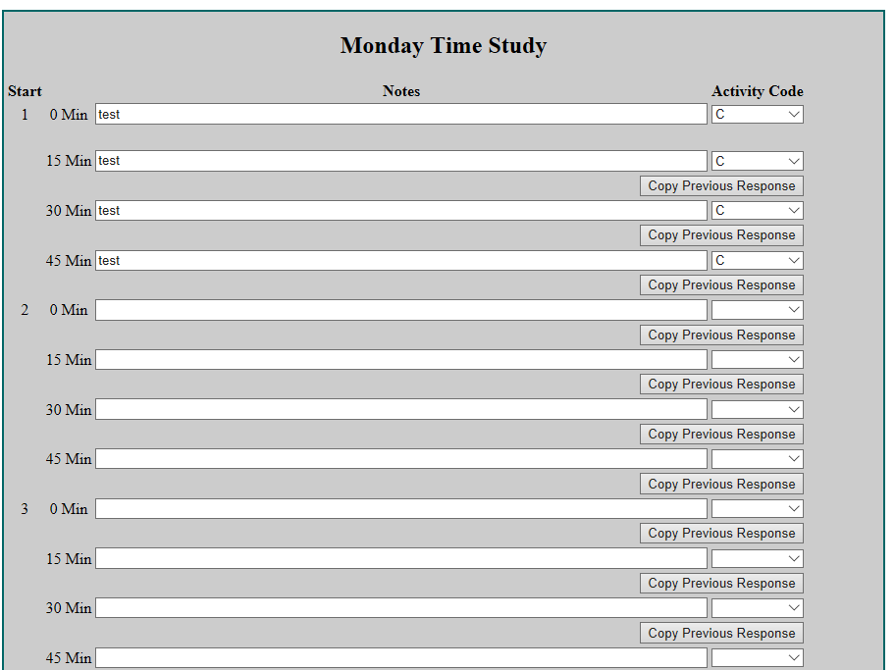

* 1. 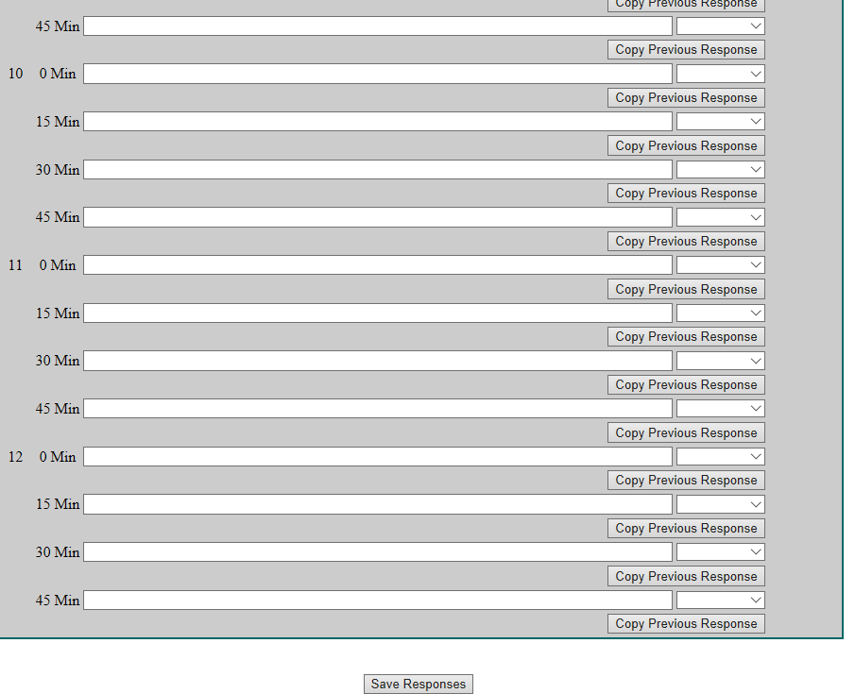Once the participant has completed the time study week, they will electronically sign the signature page. If there is a note or code missing, a popup notification will appear and indicate what they need to complete before signing.

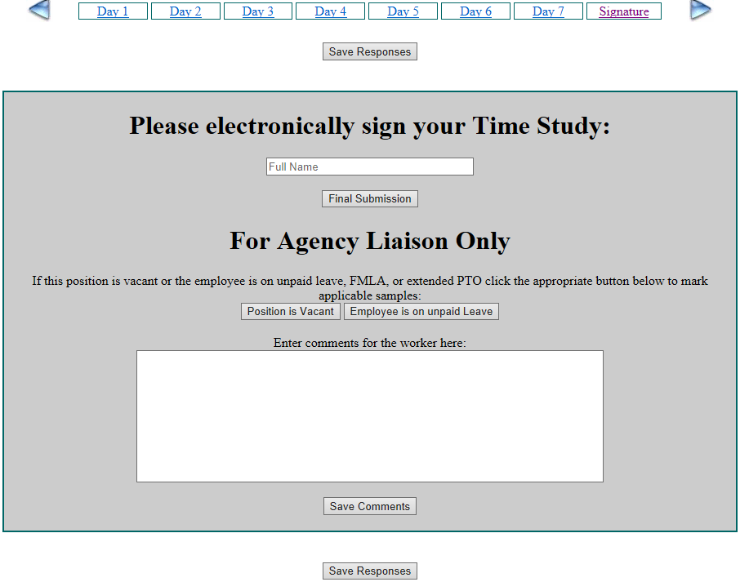



* 1. The three buttons on the top of the time study will:
     1. I do not work weekend – prepopulate weekends to “not scheduled to work – code O”
     2. I am on unpaid leave – prepopulate entire study to “employee on leave for the time study – code O”
     3. This position is vacant – prepopulate entire time study to “this position is vacant – code O”
  2. Participants are categorized as either NON-SPMP or SPMP, this is important to send the correct time study to the correct participant
     1. NON-SPMP have 15 codes to choose from
     2. 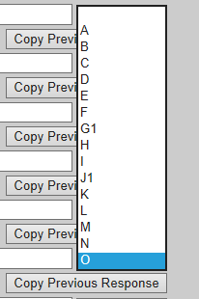SPMP has 17 codes to choose from (adding G2 & J2)
  3. Tracking
     1. 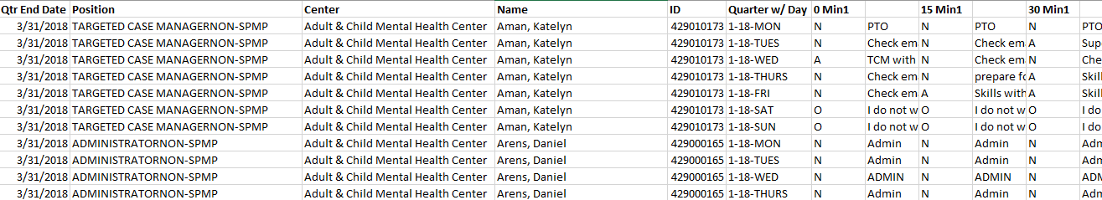Excel spreadsheet for each agency that includes code descriptions for each 15 minute increment
     2. Excel spreadsheet that includes all agency information with only selected codes

